Assessment Schedule – 2013

Chemistry: Demonstrate understanding of equilibrium principles in aqueous systems (91392)
Evidence Statement
Q | Evidence | Achievement | Achievement with Merit | Achievement with Excellence
ONE  (a) | HCl < CH₃NH₃Cl < CH₃NH₂  HCl, a strong acid, reacts completely with water to form 1 mol L^{–1} H₃O⁺ and hence a low pH.  HCl + H₂O → H₃O⁺ + Cl–  CH₃NH₃Cl dissociates completely in water to form CH₃NH₃⁺ and Cl–. CH₃NH₃⁺, a weak acid, partially reacts with water to form less than 1 mol L^{–1} H₃O⁺ and hence a higher pH than HCl.  CH₃NH₃Cl → CH₃NH₃⁺ + Cl–  CH₃NH₃⁺ + H₂O  CH₃NH₂ + H₃O⁺  CH₃NH₂, a weak base, partially reacts with water to form OH– ions. So there are more OH– ions than H₃O⁺ ions and the pH is thus high.  CH₃NH₂ + H₂O  CH₃NH₃⁺ + OH– | - Correct order.  - TWO equations correct.  - Recognises that HCl dissociates completely in water.  OR  Recognises that CH₃NH₃⁺OR CH₃NH₂ only partially react with water. | - THREE correct equations.  - Recognises that HCl dissociate completely in water.  AND  Recognises that CH₃NH₃⁺ or CH₃NH₂ only partially react with water. | - Discusses all the reactions correctly including concentrations of OH– and H₃O⁺ ions.
(b) | HCl = CH₃NH₃Cl > CH₃NH₂  CH₃NH₃Cl and HCl will dissociate completely in water to produce 2 mol L^{–1} ions.  CH₃NH₂ will only partially react with water to produce less than 1 mol L^{–1} of ions. | - CH₃NH₂ written last.  - Links concentration of ions to degree of conductivity. | - CH₃NH₂ written last and discusses HCl / CH₃NH₃Cl AND CH₃NH₂.  Links concentration of ions to degree of conductivity. | - Correct order with valid discussion. Links concentration of ions to degree of conductivity.
(c)(i) | 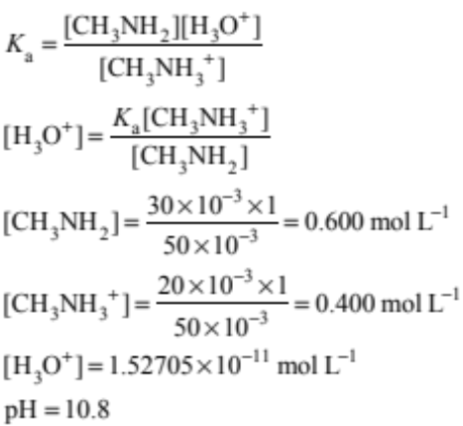  Candidates should not be penalised for using ratio of volume and getting correct answer. | - Correct K_{a} expression.  OR  - pH = pK_{a} + log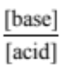  OR  Correct concentrations or number of moles. | - Correct process with minor error. | - Correct answer.
(ii) | When a small amount of acid (H₃O⁺) ions are added, they will react with the CH₃NH₂(aq) molecules to form CH₃NH₃⁺(aq) ions.  CH₃NH₂(aq) + H₃O⁺(aq) → CH₃NH₃⁺(aq) + H₂O()  The added acid (H₃O⁺), is mostly consumed, and the pH of the solution changes very little. | - Correct equation.  OR  Shows understanding that CH₃NH₂(aq) reacts with added acid.  OR  Discusses minor reaction of OH– + H₃O⁺. | - Correct equation.  AND  Shows understanding that CH₃NH₂(aq) reacts with added acid. | Correct equation and correct discussion of reaction.

Not Achieved | NØ | No response or no relevant evidence
Not Achieved | N1 | 2a
Not Achieved | N2 | 3a
Achievement | A3 | 4a
Achievement | A4 | 5a
Merit | M5 | 3m
Merit | M6 | 4m
Excellence | E7 | 3e with minor error / omission / additional information.
Excellence | E8 | 4e

Q | Evidence | Achievement | Achievement with Merit | Achievement with Excellence
TWO  (a) | K_{s} = [Ag⁺]²[CrO₄^{2–}] | - Correct K_{s} expression.
(b)(i)  (ii) | 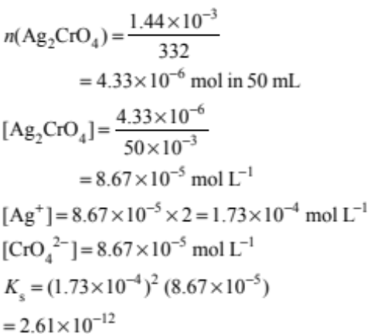 | - Correct process  OR  Correct answer with limited working  - Correct ratio of [Ag⁺] : [CrO₄^{2–}]  - Uses 4s³ with incorrect answer. | - Correct concentration of silver chromate calculated. | - Correct solubility concentration values for each ion and Ks value.
(c) | Dissolving 0.0100g of silver chromate in 50 mL water will result in solid being present, as the required amount to make a saturated solution is 1.44 × 10^{–3} g in 50 mL, so any more than this will form a solid.  If the same mass is added to 50 mL of ammonia, more will dissolve and less solid will be present due to the formation of a complex ion.  The Ag₂CrO₄ will dissociate completely and form an equilibrium.  Ag₂CrO₄  2Ag⁺ + CrO₄^{2–}  Ag⁺ + 2NH₃  [Ag(NH₃)₂]⁺  The silver ion will then react further with NH₃, removing it from the above equilibrium. Thus, more Ag₂CrO₄ will dissolve to re-establish equilibrium. | - Recognises that more dissolves in B.  - Recognises that a complex ion forms. | - Recognises that more dissolves in beaker B with link to an equation.  - Recognises that in ammonia a silver complex ion will form. | - Links equilibrium of silver chromate with silver & ammonium complex ion removal and hence more dissolves.  - Recognises  0.0100 g > 1.44 × 10^{–3}, therefore solid Ag₂CrO₄ is present.  - Correct equation of formation of complex ion.

Not Achieved | NØ | No response; no relevant evidence.
Not Achieved | N1 | 1a
Not Achieved | N2 | 2a
Achievement | A3 | 3a
Achievement | A4 | 4a
Merit | M5 | 2m
Merit | M6 | 3m
Excellence | E7 | 2e
Excellence | E8 | 3e

Q | Evidence |  |  | Achievement | Achievement with Merit | Achievement with Excellence
THREE  (a) | 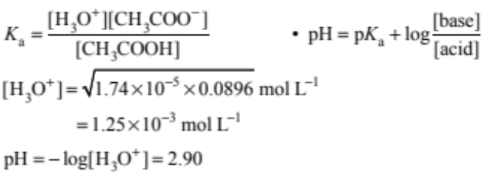 |  |  | - Correct process. | - Correct pH. | (a) & (b) correct.
(b) | Halfway to equivalence point, half of the ethanoic acid has been used up. There are now equimolar quantities of ethanoic acid and sodium ethanoate.  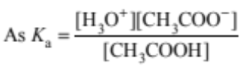  According to the equation when [CH₃COOH] = [CH₃COO–]  then K_{a} = [H₃O⁺]  So pK_{a} = pH. |  |  | - Recognises that there are equimolar quantities of ethanoic acid and sodium ethanoate. | - Relates equation correctly to explanation.
(c)(i) | NaOH(aq) + CH₃COOH(aq) → NaCH₃COO(aq) + H₂O(l) (1)  [CH₃COO–] increases as it is formed in reaction (1).  [Na⁺] increases as NaOH is added (1).  [CH₃COOH] decreases as it reacts with NaOH (1).  [H₃O⁺] decreases because [CH₃COO–] / [CH₃COOH] increases and K_{a} is a constant.  [OH–] increases because [H₃O⁺] decreases and [H₃O⁺] [OH–] is constant. |  |  | - Correct equation minor error.  - Correct statement relating to change in concentration of 1 species. | Correct equation and correctly describes the change in concentration of 2 species. | - Correct equation.  AND  Correctly describes the change in concentration of the 4 species.
(c)(ii) | n(CH₃COOH at start) = 0.0896 × 20 ×10^{–3}  = 1.79 × 10^{–3} mol  n(NaOH added) = 0.1 × 5 × 10^{–3}  = 5 × 10^{–4} mol  After 5 mL NaOH added:  n(CH₃COOH) = 1.29 × 10^{–3} mol  n(CH₃COO–) = 5 × 10^{–4} mol  [CH₃COOH] = 0.0516 mol L^{–1}  [CH₃COO–] = 0.0200 mol L^{–1}  [H₃O⁺] = 4.48 × 10^{–5} mol L^{–1}  pH = 4.35  Candidates will not be penalised for not calculating concentrations. |  |  | - Correct n for CH₃COOH OR NaOH at the start. | - Correct process to identify either of the species after 5 mL has been added (mol or mol L^{–1}). | - Correct answer.
Not Achieved |  | NØ | No response; no relevant evidence.
 |  | N1 | 1a
 |  | N2 | 2a
Achievement |  | A3 | 3a
 |  | A4 | 4a
Merit |  | M5 | 2m
 |  | M6 | 3m
Excellence |  | E7 | 2e
 |  | E8 | 3e with one minor error

Judgement Statement
 | Not Achieved | Achievement | Achievement with Merit | Achievement with Excellence
Score range | 0 – 6 | 7 – 12 | 13 – 18 | 19 – 24

